**KGR-ROTARACT**

REPORT

ON

**"DISTRIBUTION OF FOOD"**

BY

( SECRETARY ) Rtr. SHIVANI GUPTA

KGR-ROTARACT. HoD-DSA. PRINCIPAL

( Secretary )

**OBJECTIVE OF PLANTATION**

Essentially, food and nutrition programmes try to improve consumption of food in situations where people are left with relatively limited or poor quality food choices (which can be due to supply and/or demand characteristics). Especially under these conditions, but not exclusively, the allocation and distribution of food to and within groups or households becomes relevant.

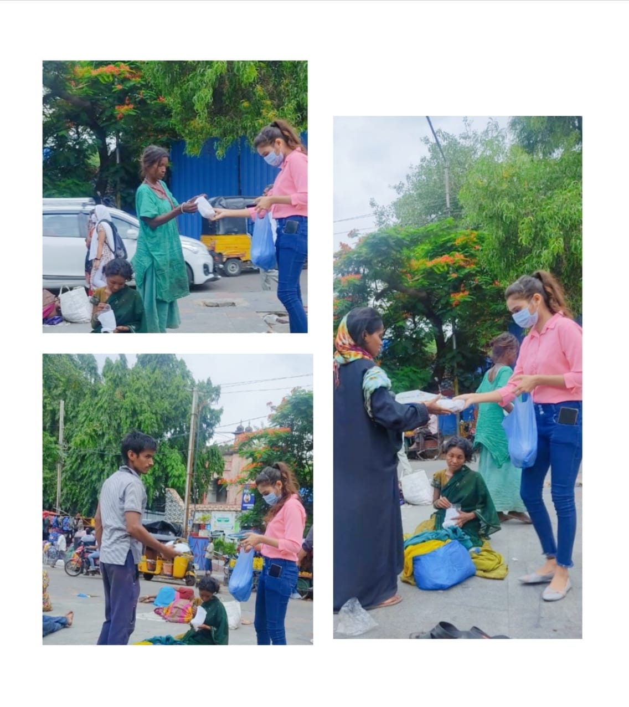 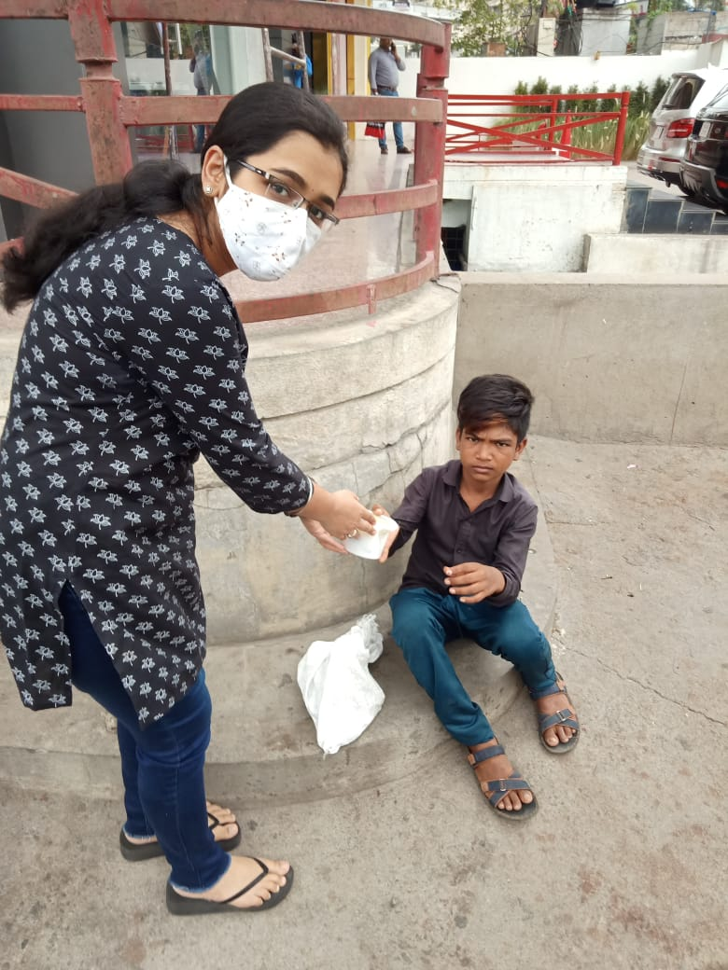

Rtr. Shivani Gupta Rtr. Sonal Singh

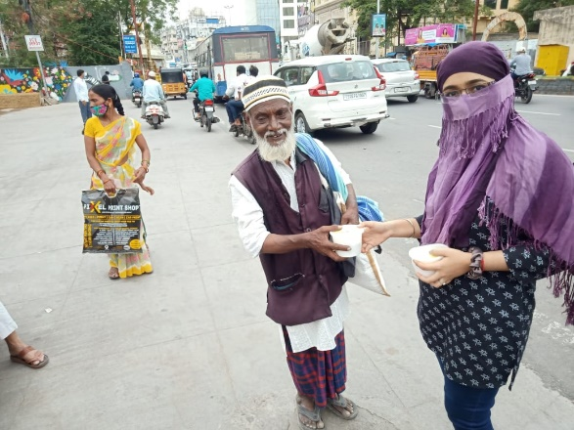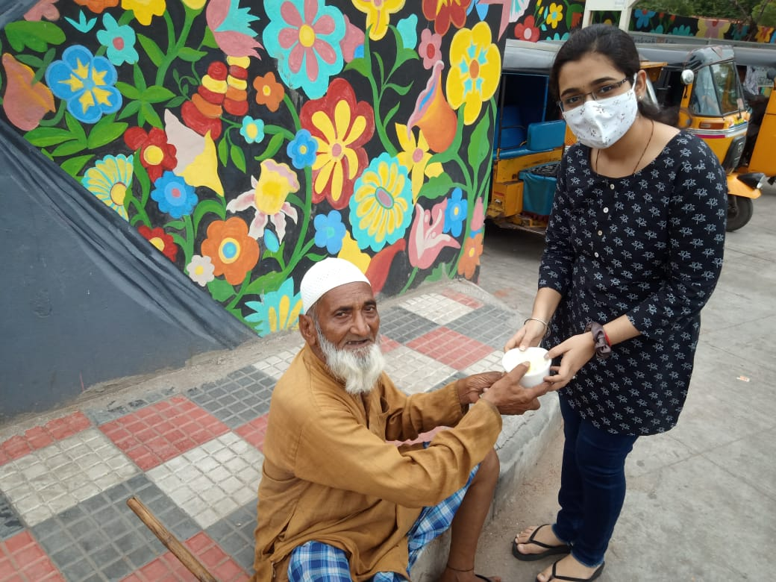

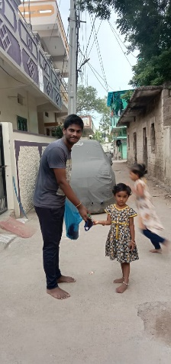 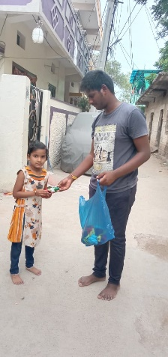 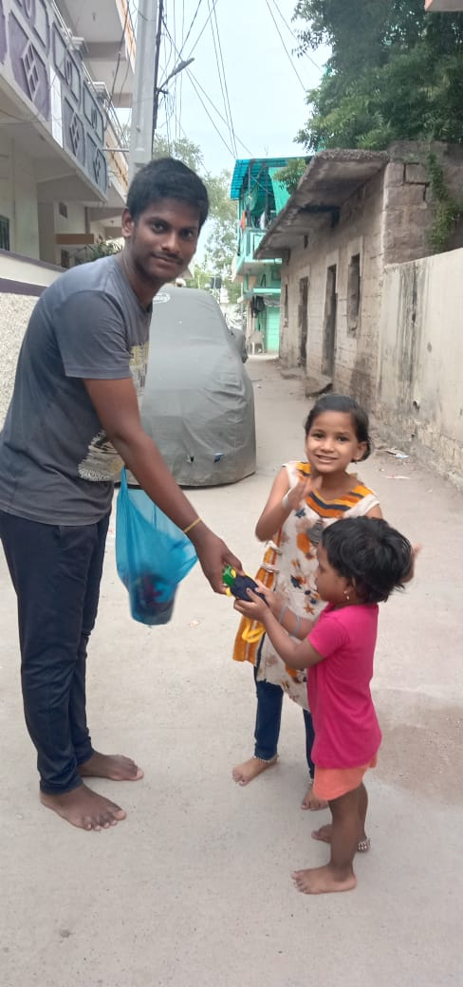

Rtr. Nikil

